**Smart Dustbin System**

**PURPOSE:**

With increase in population we have an increase in the garbage around urban areas. Here we propose

a smart dustbin that operates automatically to help solve this issue using IOT and sensor based

circuitry. Usual dustbins require to be opened by pressing foot against its lever and then throwing

garbage. Also a person needs to keep track when it is full so that it can be emptied and does not

overflow. Here we propose a smart dustbin that does all this by itself. Our system consists of a sensor

in order to detect human clap signal and on a clap of foot tap it opens automatically without anyone

needing to press its lever. The dustbin opens automatically when it receives the signal and closes its

hatch. Also the dustbin consists of a level sensing ultrasonic sensor that constantly measures the level

of garbage in the bin and automatically detects if it is about to fill up. The dustbin now consists of a

smart circuitry that transmits this information over the web to signal the main garbage collector of

the facility to empty the particular garbage bin. We use IOTgecko to develop the online web part for

the iot system. This bin is of a vast usage in offices, homes and even in public places for garbage

management. Thus we get a fully automated smart dustbin that allows for automated garbage

cleaning.

**FUNCTIONALITY:**

1. The dustbin opens automatically when it receives the signal and closes its hatch.

2. System consists of a sensor in order to detect human clap signal and on a clap of foot tap it opens

automatically without anyone needing to press its lever.

3. Dustbin consists of a level sensing ultrasonic sensor that constantly measures the level of garbage

in the bin and automatically detects if it is about to fill up

4. Dustbin consists of a level sensing ultrasonic sensor that constantly measures the level of garbage

in the bin and automatically detects if it is about to fill up

**TARGET AUDIENCE:**

⮚ The primary audience who will be using and benefitted from our application will be citizen of

our society.

**SCOPE:**

Sensor Based Waste Collection Bins is used to identify status of waste bins if it is empty or filled so

as to customize the waste collection schedule accordingly and also save the cost. Real time waste

mangement system by using smart dustbins to check the fill level of dustbins whether the dustbins

are full or not, through this system the information of all smart dustbins can be accessed from

anywhere and anytime by the concern person. It will inform the status of each and every dustbin in

real time so that concerned authority can send the garbage collection vehicle only when the dustbin is

full. By implementing this system resource optimization, cost reduction, effective usage of smart

dustbins can be done.

**References:**

<https://www.projectsof8051.com/gsm-based-garbage-and-waste-collection-bins-overflow-indicator/>

<http://nevonprojects.com/iot-garbage-monitoring-system/>

**Research Paper:**

<http://mobilityresearchforum.com/ncpd2016/wp-content/uploads/2016/08/NCPD2016_paper_49.pdf>

<https://www.ijariit.com/manuscripts/v2i5/V2I5-1185.pdf>

<http://ijesc.org/upload/111632bcb05ca85895d204c4874efe8b.Smart%20Dustbin-An%20Efficient%20Garbage%20Monitoring%20System.pdf>

<https://www.ijser.org/researchpaper/Smart-Bin-Implementation-for-Smart-Cities.pdf>

<http://ijarece.org/wp-content/uploads/2016/06/IJARECE-VOL-5-ISSUE-5-1576-1578.pdf>

<http://pep.ijieee.org.in/journal_pdf/11-132-1431516577101-104.pdf>

**Work Done:**

**Risk Table:**

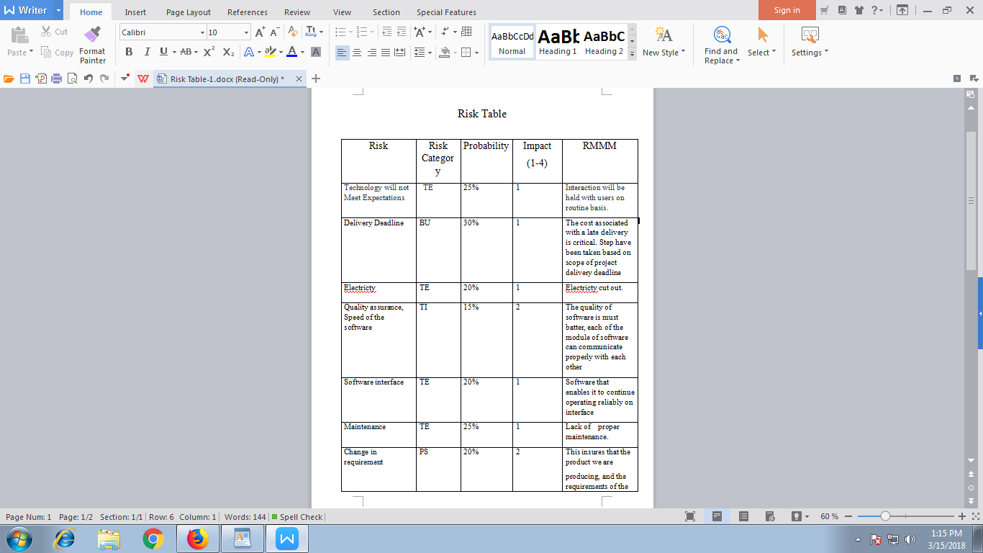

**Traceability Matrix(RTM):**

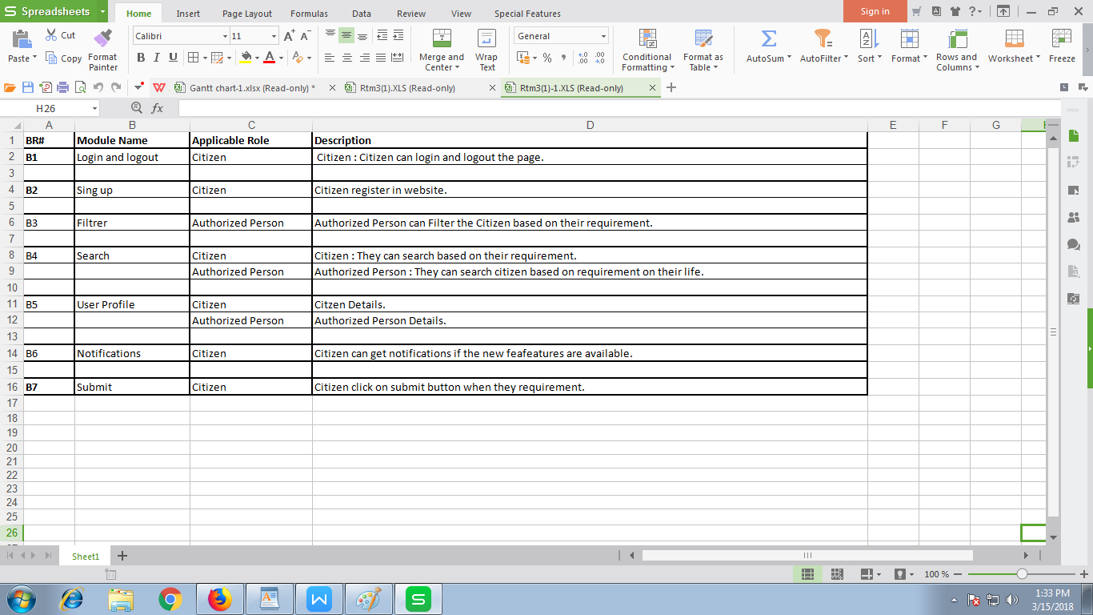

**Gantt Chart:**

